Central Western Maine Workforce Development Board Meeting Minutes
October 25, 2018 (9:00 –11:00)
Maine Manufacturers Extension Partnership
87 Winthrop Street, Augusta, ME
877-647-3411 # 592287

Attendance:
Board Members (In person or by phone): Craig Nelson, Muriel Mosher, Dale Morrell, James Trundy, Mary LaFontaine, Erika Douglas, Harvey Smith, Diane Frigon, Linda D’Alessandro, Amy Landry, Razell Ward, Brittany Blais, Laurie Glidden, Brian MacLeod.
Special Guests: Mark Winter, Senator Angus King’s Office, Karen Staples, Congressman Bruce Poliquin’ s Office, David Duguay, Oxford County Commissioner, Robert Sezak, Somerset County Commissioner & CEO Chair, Larry Post, Androscoggin County Commissioner (by proxy), Terry Brann, Franklin County Commissioner, Joshua Howe, SWB Acting Director, and Derek Fassett, Maine Apprenticeship Program (speaker).
Excused Absence: Chris Greenleaf, Michelle Hawley, Kelly Aho, Justin Walsh
Staff: Harry Simones and Sara McLaughlin

The meeting started with introductions by everyone present in the room and 9 people who joined us by phone.

First item of business was approval of the minutes from the 6/28/18 Board Meeting. It was moved by Harvey Smith and seconded by Brian MacLeod and all approved the 6/28/18 meeting minutes.

The financial/budget report was presented by Sara McLaughlin. Discussion ensued on going from a temporary budget to get us through the end of 2018 or possibly March 2019 on PY17 money …….to a new budget once we receive our PY18 money from MDOL. An Ex Committee meeting will be scheduled in the next two weeks in a working session to come up with a new more permanent budget of 2019 and deciding the composition of the CWMWDB staff, Ex Director, Director of Employer Services, Admin Asst, etc., salaries, posting of positions, location, lease agreements, rent, etc.

Harry talked about the status of the PY 18 budget which was approved by the Governor and Commissioner Butera and is currently at the Special Purchase Review Committee(SPRC) according to Ed Upham, Bureau of Employment Services Director. Should get final approval soon per Ed Upham. Once approved the Ex Committee and Sara will develop a new permanent budget for the rest of 2018 and 2019 as mentioned above. We will also have to set up an RFP Committee to develop a new RFP proposal to go out to the public early next year to bid on delivering all Career Services under WIOA Title 1B for all of Androscoggin, Oxford, Franklin, Somerset and Kennebec Counites. A second review and scoring committee made up of non-partisan members will be chosen to objectively score the applicants and make a fair award of the new contract for PY19 and PY 20 WIOA services to our local area.

The Board reviewed and approved changes to our Individual Training Accounts policy. The effective date of the changes are 10/25/18 with a review date of 10/25/20. The changes approved to the policy were deletion of III.2.d. “ITAs may include fees for books, special fees, levied by eligible providers, educational materials, clothing/footwear, necessary for training to the extent documented in Area III’s Local Area.” (These items are now covered under Supportive Services).
The second change to this policy was V.6. Limitations on ITA’s: ITA’s may be written for credentials such as degrees, certificates, and occupational licenses. ITA’s will be written for no longer than 2 years. Any exception to the time limit must be reviewed by the CareerCenter Manager and approved in writing by the Executive Director of CWMWDB.
These changes were Moved and Seconded by Muriel Mosher and Mary LaFontaine respectively. All approved with one abstention: James Trundy.

We had a short report out by Amy Landry, Executive Director of Androscoggin Valley Council of Governments on a new initiative to expand public transportation in the L/A area to get workers and job seekers to our major manufacturers and employers using the public transportation system. Here’s a link to a Mainebiz article related to workforce and public transportation: www.mainebiz.biz/article/20181029/CURRENTEDITION/310249995/1092?utm_source=enews&utm_medium=Daily%2BReport&utm_campaign=Wednesdayy

The second policy approved by the Board was a new policy developed for Customized Training (effective date is 10/25/18 with a review date of 10/25/19). The policy is based on guidance from the Maine Department of Labor/Bureau of Employment Services. This policy defines Customized Training as “training designed to meet the special requirements of an employer (or group of employers) that is conducted with a commitment by the employer to employ the individual upon successful completion of the training, for which the employer pays a significant cost of the training as determined by LWDB policy taking into account.” This policy was moved and seconded by Mary LaFontaine and Brian MacLeod respectively. All approved with 2 abstentions: James Trundy and Dale Morrell.

We had a presentation on Maine’s Apprenticeship Program by Derek Fassett from the Department of Labor, derek.c.fassett@maine.gov who spoke on how we can best use apprenticeships to develop and train our workforce for youth, adults, Veterans, the disabled, and our prison population either in pre or post release. A Powerpoint handout was provided to Board and CEO members with lots of good discussion and questions on apprenticeships from some of our members including Dale Morrell and Brittany Blais from St. Mary’s, Harvey Smith from Kennebec Technologies, Mary LaFontaine from MDOL, and Diane Frigon from Bureau of Rehabilitation Services. A new idea and approach for employers is to reach out directly to their local schools and educators and to encourage them to foster relationships with the students to expose them to the viability of this alternate pathway to a career and a skilled occupation.
Harry presented highlights from his activity report to the board including finally after three and half months getting our System for Award Management (SAM) approved by the Federal government(Yea!) Without this approval and activation, we would be unable to receive Federal funds for training.
Meetings with the Maine Community College System Workforce Development Department, Somerset Workforce Connect, the Lewiston-Auburn Transportation Committee, L/A Chamber of Commerce Education and Workforce Development Committee, Business Services Team for our 5-county area at the Lewiston CareerCenter, KVCOG, fcNET in Franklin County, recruitment of new board members and CEO for Androscoggin County, Case Monitoring and MJL training with Ginny Carroll from MDOL, SWB, Steering Committee and Cross Training Meetings with all of our WIOA partners, and more as detailed in my report.
A special presentation and plaque was presented to Muriel Mosher, President of Maine Manufacturers Extension Partnership for her 8 years of service on our Board and Executive Committee as she will be retiring in December. Muriel will be greatly missed by all.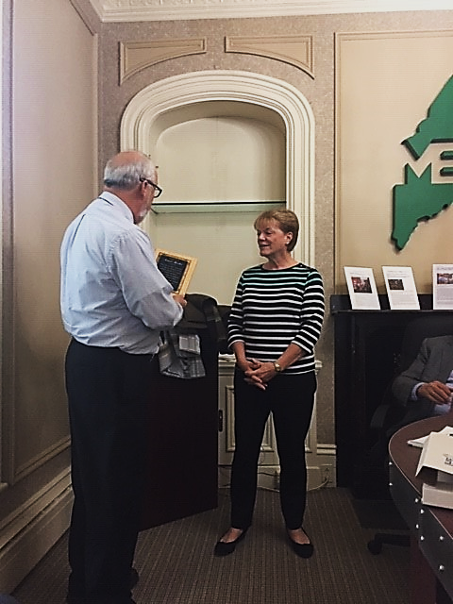
James Trundy also thanked Brian MacLeod from Barclays US for his service to our Board as he’s leaving for a new position in Brunswick with Wayfair. Thank you, Brian.
There was a discussion of future dates for Board meetings being either on the last Wednesday, Thursday or Friday for our quarterly meetings. It was decided to postpone that decision until December as the Board will most likely have a special meeting to approve a new budget for 2018-2019 after a special Ex Committee meeting in a couple of weeks.
A motion was made and approved for adjournment at 10:48.

Submitted by:

Harry J. Simones harrysimones@cwmwdb.org
Acting Executive Director
CWMWDB
10/31/18

