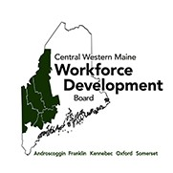
Narrative Report

wmca

Western MainQ Community Action Helping People• Changing Lives

Service Provider 3rd Quarter Report

WMCA staff have been meeting with BES staff in our 5-Co area to review CSSP case files for possible co­ enrollment in WIOA. The state is running low on CSSP funds and is seeking ways to stretch the budget. WMCA staff will co-enroll participants who meet the WIOA eligibility and whose plans fall within our local training policies. Currently it looks as if we'll have about 30 enrollments.
WMCA staff met with BES staff at the Augusta CareerCenter to re-establish a bi-weekly CareerCenter services orientation. The purpose is to help people, especially those interested in training, with learning the various types of assistance available. This process is a more efficient way to disburse information. WMCA staff from Lewiston will assist as necessary.
WMCA and BES met with staff from DECD on Feb. 20th . The purpose was to learn about each other's services and how we can work together to assist businesses. The DECD is mainly and information tunnel that helps businesses connect with providers depending on their needs.
We continue meeting with a statewide committee composed of the 3 LWDB directors, management staff from the WIOA service providers, and Ginny Carroll from BES who is the BES Director for Policy and Evaluation. The group is currently working on a data validation manual, co-enrollment policies, measurable skill gains performance outcomes, and ensuring staff are properly documenting in MJL so that reports are accurate.

We continue to be busy with projects across the area:
•
Cert. Med. Assistant with Gray-New Gloucester Ad Ed at St. Mary's started Feb. 11th
- Cert. Nurse Aide with Mid Maine Regional Ad Ed for Northern Lights started Jan. 27th
- Cert. Nurse Aide with Skowhegan Ad Ed for Mt. St. Joseph's started Feb. 3rd
- Cert. Nurse Aide with Farmington Ad Ed for Franklin Mem. Hosp. started Feb. 10th
- Truck Driving for Class A for 8 participants at Ox. Hills Ad Ed, Region 9, and Keep Right in
Skowhegan
•
Ed Tech III with Lewiston Ad Ed staiied 3 students in January
•
Completed the first technical support training for Carbonite and started 2 on OJT

Working on the next round of construction training for the greater Lewiston area; 2 applicants did not need the full training and have been placed directly with employers.
After our tour at Origin in Farmington, we've maintained contact and preparing to staii our first OJT in March.

WIOA Quarterly Report Q 3

Central Western Maine
-----Quarter Ending 3/31/20

Employment 2nd Quarter After Exit Median Earnings 2nd Quarter After Exit

Program Report  Value | Adults | DW | Youth | Program Report  Value · | Adults | DW
(Actual)  Negotiate | 80.46% | 79.31% | 70.18% | (Actual)  Negotiate | $5,917 | $6,597.00
d Value | 76.0% | 78.8% | 71.0% | d Value | $4,950.00 | $6,800.00
Performan | 105.9% | 100.7% | 98.8% | Performan | 119.54% | 97.01%

Employment 4th Quarter After Exit Enrollments Accumalitive
Program Adults DW Youth Program Adults DW Youth Report
Value
(Actual) 75.49% 75.47% 82.42% Proposed 113 65 131 Negotiate
d Value | 72.0% | 75.0% | 71.0% | !Actual I | 1301 | 431 | 561
Performan | 104.8% | 100 .6% | 116.1%

Credential Attainment During Measurable Skill Gains

Program Report  Value | Adults | DW | Youth | Program  Report Value | Adults | DW | Youth
(Actual)  Negotiate d Value | 68.89%  61.0% | 66.67%  60.0% | 81.28%  49 .0% | (Actual)  Negotiate d Value | 37.29%  Baseline | 42.86%  Baseline | 53.13%  Baseline
Performan 112.9% 111.1% 165.9% Performance Score

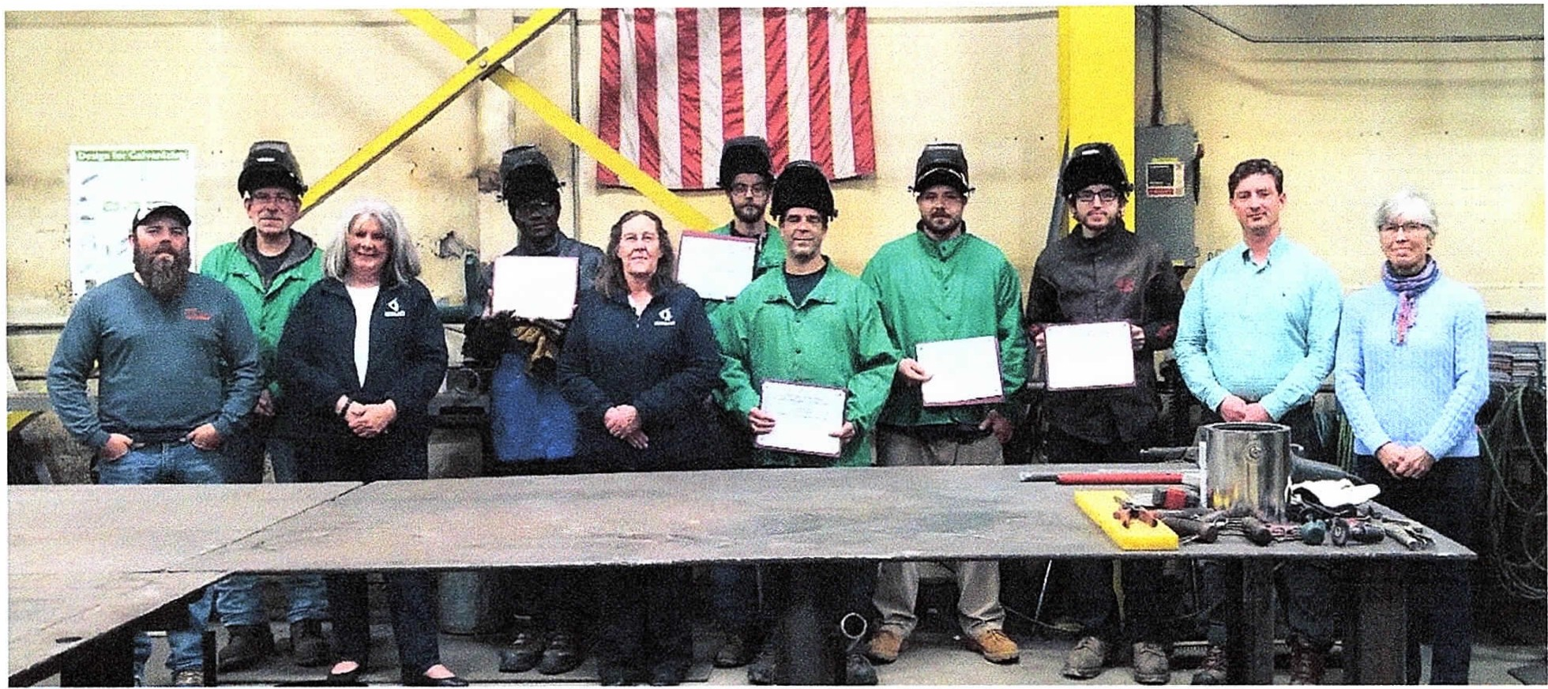

Workforce Training Partners Graduate Welding Students
Photo caption: Bancroft Contracting Corporation, and Workforce Training Partners Western Maine Community Action (WMCA) and Oxford Hills/Nezinscot Adult Education
(OH/ NAE) . hosted a graduation at the Bancroft facility in South Pa ris for graduates of the Customized Welding Training Program on Thursday, October 17th to award completion
cert ifi cat es and celebrate the successful completion of the second welding Cohort . Pictured (I­
r): Kyle Lamb, Bancroft Project Manager; Fred Locke, Bancroft Welding Inst ruct or; Monica Millhime, WMCA Regional Employer Assistant Point; Toma Bakoula, welding candidate; Cathy St ai rs, WMCA Employment & Training Specialist; Donald Ingerson, Fern Dulac, Morgan
Gam mon, Nick Reavis, welding candidates; Joseph Costello, Bancroft Vice President/HR and Tina Christ opherson, OH/NAE Director . Not available for photo Greg Aptt . Photo Courtesy Heidi Durgin, OH/ NA E.

Western Maine Community Act ion, located at the CareerCe nt er in Lewiston, and Oxford Hills/Nezinscot Adult Educat i on, partnered with Bancroft Contracting Corporation in South Paris to provide a second cohort for a customized professional welding program. Students Greg Aptt, Fern Cohort, Donald Ingerson, Toma Bakoula, Morgan Gammon and Nick Reavis successfully completed the 72-hours of hands on welding inst ruct ion , safety training, and 20-hours of math for welders, and job-readiness skills training on October 17th . The 92-hour long program offered students welding processes used by Bancroft Contracting Corporation and other local employe rs. " Lo w unemployment, combined with an aging work fo rce, create employment gaps that require diff erent approaches to fill need s," shares Patti Saari nen, WMCA Program Coordinator - Central/Western Maine CareerCenters. "Combining private industry, education and job training is an efficient and resourceful way to meet the challe nges." For more information on other programs available for training and part nershi ps, 207-753-9001. Visit https://www.facebook.com/WesternMaineCommunityAction/ and htt ps:/ / wmca.org/ for upcoming opportunities for workforce t raining.

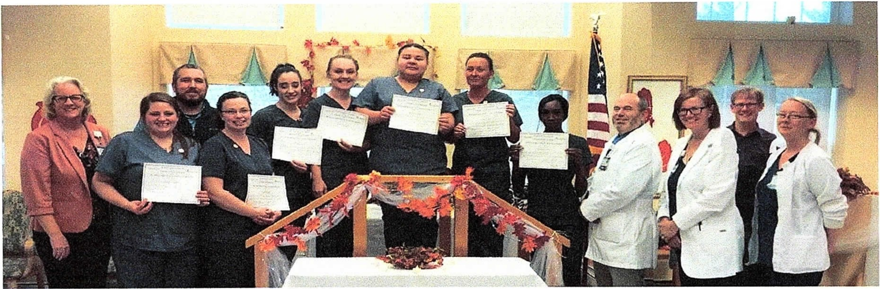

Workforce Training Partners Honor Certified Nurse's Assistants Pictured {l-r) : Robin Doody, Northern Light Health Talent Acquisition Specialist. ; Chelsea Whitmore , CNA; Ryan Francis, Northern Light Continuing Care Lakewood (NLCCL} Assistant Administ rator ; Katie Johnson, Aime
Worcester , Karina Wright, Michaela Brown, Jessica Lew is, Shannevia Yarns, CNAs ; Chris M iller, NLCCL Class/Clinical Inst ructor ; Patricia Shuck, NLCCL Director of Nursing; Myles Robert, Western Maine Community Action (WMCA) Employment & Training Specialist ; and Desiree Knowles, NLCCL Assistant Director of Nursing . Photo courtesy of Monica M illhime, WMCA.
Waterville - Seven students successfully completed a collabo rat ive program of 180 hours of a Certified Nurse' s Assistant training provided by workforce training partnerships with Western Maine Community Action (WMCA) at the CareerCenter in Lewiston and Mid-Maine Regional Adult Community Education in Waterville.. Northern Light Continuing Car e Lakewood (NLCCL) in Waterville, hosted a graduation ceremony at the facility on Fri day, November 15^{t} ^{h} recognizing graduates as Certified Nurses
Assistants. Patricia Shuck, Director of Nursing, welcomed administ rat or s, staff, resi dents, family , friends, teachers and community partners to the pinning ceremony and presentation of
cert ifi cat es. Commencement remarks were shared by Class/Clinical Instructor, Chris Miller, R. N. Class/Clinical Inst ruct or; Ryan Francis, Assistant Administ rat or; Monica Millhime, WMCA Regional Employer Assist ant Point ; Vicki Dyer , LPN; and Desiree Knowles, R. N. Assistant Director of Nursing . The classroom/clinical curriculum, in addit ion to an On-the-Job program following graduat ion, empowers students with the skills and knowledge essential to the specific job field, 11Working in healthcare requires not only technical skills but patience and compassion as well. Working with partners who understand the needs and can guide st u dents through all aspects of the job makes the t rai ning meaningful. We are so grateful to our partners at NLCCL for the fine job they do." shares Patti Saarin en, WMCA/WIOA Site Coordinator serving Androscoggin, Franklin, Oxford, Kennebec and Somerset
Count ies. 11 The grant funding was very well spent. Our new team members are vibrant and so well prepare d," shares Shannon Lock wood, NLCCL Administ rat or. 11There are many ways this program ensures that we find the right people with the right skills and the right personality for this profession. We are grateful for the opportunity to benefit from this grant and the students are enthusiastic and excited about this rare and free opportunity to be paid to learn ."
" It' s exciting to open doors for individuals looking for a new career opport unit y. NLH Continuing Care Lakewood has done just that by partnering with Adult education and WMCA to train and certify new Certified Nursing Assist ant s. This is a win-win for all," shares Talent Acquisitions Specialist, Robin Doody. The next class begins January 27. FMI email Doody at rdoody@northernlight.org by January 3.

2/28/2020 http s://twincitypub.pageflip.site/editionsfTCT54447/pages/1/print

FREE• Vol XXJ, No . 49 Your Hometown Newspaper Since1999 Thursday, February 27, 2020 • FREE

Pinky D's Poutine
One Vear Anniversary Party
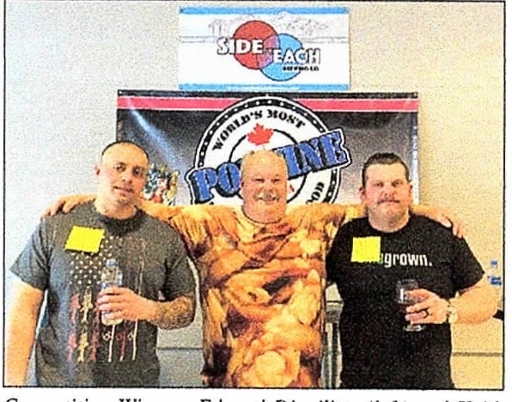
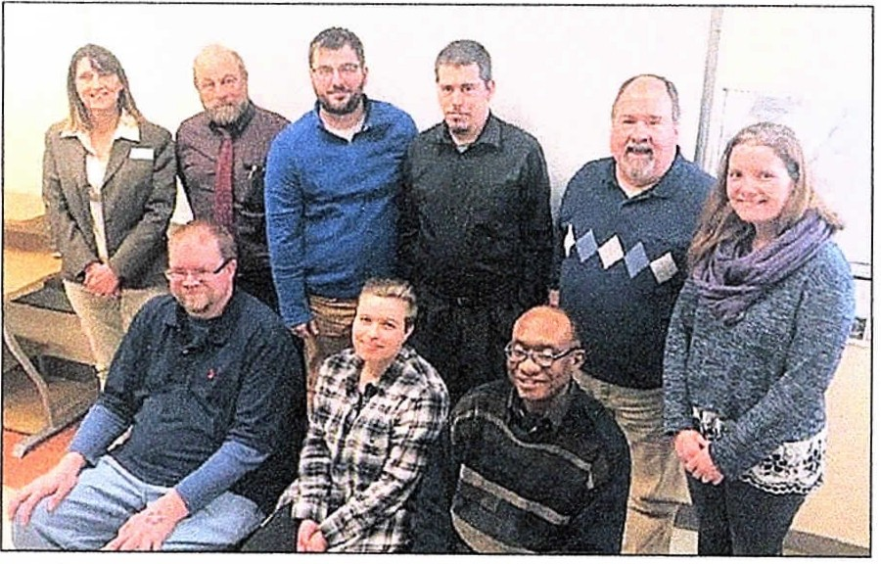
Beech Rid ge Speedway tickets. and the ultim ate prize of free poutine for a year!
Technical support professionals celebrate program completion

Compc1i rio11 Wim1l•rs Edward Dippilirto (h.11) and Ki•ifh Suwuler,\· ( ri ght) picmred with Pinky D'.\· fowuler Rwuly Smith. Twin City 7imcs 11hnto by Millie Barnard.
At 2 p.m. five tenms competed in a pout i m:: caling competi­ tion for$ I 00 value prize. The five team s were composed of two mem­ bers give n 30 min utes to eat 12 pounds of pou­ tin e ! Th e winners. Keith Savnder s a nd Edward Dippilino (te am The Dirty Bu rger) won. al­ most finishin g th e ir bowl of pouli ne (less than 2 pounds left!).

On Satu rday, Feb­ ruary 22 , people g ath­ ered from all aro un d the communit y at Pinky D's Poutine and Side
fun filled day of pouti nc e ating , beer tasting am.I door prizes!
The door prize s
included Reel Sox Tick-
Videos of th e con­ tes t can be found on Twin City Time's Face­ book page.
Music for th e
Wurkfurn Dc1•e/opme111 Parlncrs co11gra111/a1ed stucle111s who rccc11tly comµlet<•d the Teclmictll Sup port Professio nal trai11i 11g. Pic:wretl back (l-rJ: Christina King, \YMCA, B11rry Mt1gd11, CMCC , Allen-Mi clwe. S1. Claire. Micha el Vigil. Gregnry Ytues, LA£ , mu/ Jen nifer Tiner, LAE. (Semed) Craig Rt·cord, £\'ely11 Blake. and Feliden He tu . Phow courtesy of Mic/we/ Reagan. LA£.

by Eac h Br ew i ng for a c ts. Pink y D's swag. Set' Puuclm·. po g,• 8

USM/LA Senior College spring courses
Five stude nts cel­ cbrntcd the succ essful completion of Techni­ cal Support Professional train i ng, a co llaborati ve program brought together
Community College and Carbonile. The training included .t 40-Hour IT Fund amen tals Comp TI A Cert ificate and 80- Hour WorkRcady with Key­

on to Carbonite for ad­ ditional trnining funded th rough a WMCA /WIOA s ponsored On-th e- Job Training program . For more information on c<.1-

USM Lewiston
Aub urn Campus Senior College is ple ased 10 announce the upcomin g spring course offer in gs . There is a wonder fu l se ­ lect ion of courses in so many areas of inte rest.
You s hould be able to
find so methin g of inte rest if you arc a Senior (are over age 50) and look­ in g for some intellectual s1i mula1ion. Th e co urse schedule will be mailed soon. You can call and
leave a message at 753-
6610 and to get lh e cat­ alo g email e d to you. To become a member and reg iste r for classe s, visit USM .mainc.e<lu/Senior college. If any question s, See USM/LA.1xIge II
by the Maine Department
of Labor/Bureau of Em­ ployment Services. West­ ern Maine Community Action, Lewiston Adult Education. Workforce and Professio nal Devel­ opment at Central Maine
boardi ng Certificate to
he l p stud ents prepare for career paths in IT Te!chni­ cal Support. Recognition for trainin g success was he ld at 8 Street Commu­ nit y Center in Lewiston. Three stude nts plan to go
ucational partnerships and busi ness training opportu nit ies call (207) 753-9096 or visi t Im ps:// www .face book .com/ Western Maine Commu­ nit y Action / or http s:/1 wmca.org.

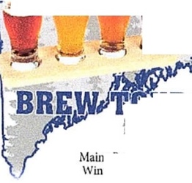
Leading the Way.
We'll do the driving!
Maine's BEST Beer Fest this winter!
I00+ Beers from Maine &
Out-of-State Breweries Unlimited beer samp les Souvenir tasting glass
Plenty of food options
Favorite tun es
Am ple space to move around Brewers servin g yo u their beers
V_A{
- ·
, -
LIiND
Saturday, February 29
$65 per person - Includes Entrance Fee & Transportat ion
Limited Seats!
- · URS
!JNORTHEAIT

nc Brewers' Guild
mtcr Session 2020
@ Brick South (I nside)
'lhomp su•n Point - Portland
Book today @ www.gonect com/bre w-bus • (207) 784-3159
I
W.E RE ONE Of MAINE'S LEADING CREDIT UNIONS FOR A REASON

WWW.DfRfGOFCU.COM I LEWISTON - AUBURN - MECHANIC FALIS - SOUTH PARIS

Movie Listings Every Week! Only in TCT. See page 13. www.FlagshipCinemas.com
See all of this week's stories and ads online. Free!
wu
W!JW!JW!J □1W!J□ [n) (G□ □ m ® ® □ ©@ m

Central Western Maine  Workforce Development Board  Androscoggin  Franklin  Kennebec  Oxford  Somerset  77 Winthrop Street, Augusta, Maine 04330 www.cwmwdb.org | 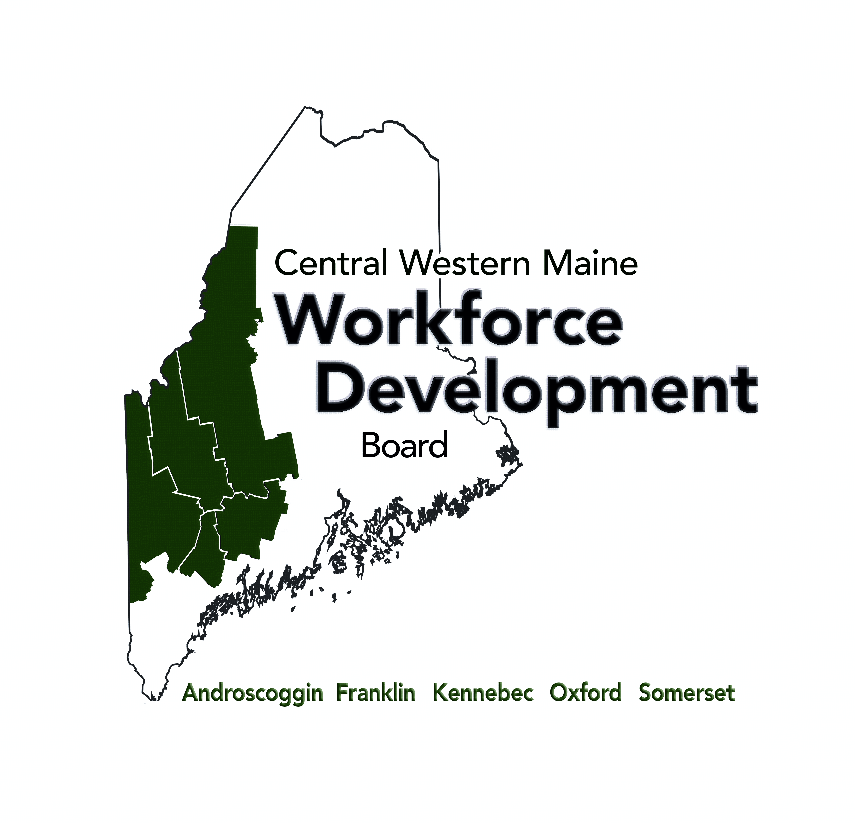
The Local Board worked on meeting its milestone State tasks.
Program Accessibility
At the beginning of the quarter, on 1/16/2020, Program Accessibility a final meeting in a series of visits was made to assess the One Stop Comprehensive Career Center, 5 Mollison Way, Lewiston, Maine for Visual Tools, Sound Equipment, Tactile touch keyboards, Multi Language Option, Self Service and Assisted Learning with staff

Publicly Bid Youth Program & OSO with Adult and DW Program
Drafted two RFPs and had them twice reviewed professionally by a lifetime, certified Certified Public Procurement Officer (CPPO), who is the Director of Procurement & Warehouse Operations for the Atlanta School System, which has almost 4,000 employees and 55,000 students. Created Public Notice for Legal Notice, Press Release for Wide release, a comprehensive web page with links to necessary documents.

Select Methodology Certifying the One Stop Comprehensive CareerCenter
On 3/26/2020 the Central Western Workforce Board selected the attached methodology as its certification process.

Begin Certification Process for One Stop Comprehensive CareerCenter
The advisory team was selected as indicated in the guidance, for Professional such as selecting a certification methodology for Certifying the One Stop Comprehensive CareerCenter and a team to provide the certification.

Memorandum of Understanding (MOU) with Infrastructure Budget
The MOU part A, which is the main part of the agreement was finalized. A list of contacts was obtained and updated. Revision to the Appendixes commenced.

Aligning Recruitment
Executive Committee and full Board approved online and digital public information improvements to communicate local information of services to employers or jobseekers.

Administrative Tasks for the NDWG Special Health Emergency Opioid grant, and to propose, budget, review, vote on, develop and advertise employee positions, and to develop and optimized and accessible website with WIOA appropriate content.

1 of 12

Central Western Workforce Development Board

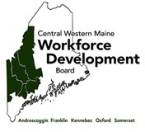
The Region 3 One Stop Center must be assessed and certified by the local board at least once every three years using criteria established under WIOA Section 121(g) and following State Policy PY16-04.
One Stop Center Certification Methodology & Strategy

The CWMWDB 2020 One Stop Certification Methodology:
- follows WIOA Section 121(g) and State Policy PY16-04 (attached);
- uses the State minimum criteria in PY 16-04 for certification;
- assesses these minimum criteria using process and result scoring dimensions from the Baldridge Excellence Framework (as allowed in State policy);
- uses additional local criteria to perform a continuous improvement self- assessment to prepare a long-term improvement plan for the next certification;
- collects scoring data in an excel spreadsheet, linking State and local criteris

The CWMWDB 2020 One Stop Certification Action Plan:
- Formulate Certification Team by 03 20 2020
  - Local Service Provider’s Career Center Manager
  - Lewiston Career Center Manager
  - Voc Rehab Career Center Representative
  - LWIB Executive Director
  - Other Regional DOL staff
- CWMWDB approves this Methodology & Strategy on 03 26 2020
- Convene Certification Team for a series of two meetings to provide information, data, verification and guidance. First meeting scheduled
- Collect scores and justifications for minimum standards from each Certification Team member
- Average scores in each dimension to achieve final result
- Prepare narrative describing minimum standard certification along with final scoring sheet
- Prepare self-assessment and plan on additional local criteria as needed (continuous improvement)
CWMWDB - ONE STOP CERTIFICATION |  | CRITERIA & IMPROVEMENT STANDARDS
# | CWMWDB Self-Assessment Criteria Local Board Continuous Improvement | State Mandated Minimum Criteria
A | Governance | State Minimum Standard | Score out  of 100 | PROCESS or  RESULTS | DOCUMENTATION  (using scoring matrix as guide)
A1 | MOU executed |  | 100 | PROCESS
A2 | One-Stop Center Operator has been selected |  | 100 | PROCESS
A3 | Functional organizational chart |  | 100 | PROCESS
A4 | EO provisions |  | 100 | PROCESS
A5 | LWIB is certified and board members are current |  | 100 | PROCESS
A6 | System in place to track customer satisfaction | Has a system in place to capture and respond to customer feedback and to ensure customer-centric service delivery and customer satisfaction (workers,  seekers and employers); and | 100 | PROCESS
A7 | There is a process for identifying and responding to  technical assistance needs of staff and partners; | Has a process for identifying and responding to  technical assistance needs of staff and partners; | 100 | PROCESS
A8 | The Center operates in a cost-efficient manner; | Operates in a cost-efficient manner; | 100 | PROCESS
B | Professional Staffing | State Minimum Standard | Score out of  100 | PROCESS or RESULTS | DOCUMENTATION  (using scoring matrix as guide)
B1 | Center staff roles and responsibilities are clear | Has a system of ensuring professional staff have the requisite abilities, knowledge and skills required to administer services, including a system for provision of continuing professional development activities on behalf of professional staff, as necessary; | 100 | PROCESS
B2 | The Center provides staff development |  | 100 | PROCESS
B3 | The Center has a system in place to assess staff members’ skills and core competencies |  | 100 | PROCESS
B4 | Equal Opportunity Awareness. Center staff and program partners are familiar with applicable laws, regulations and policies regarding nondiscrimination and equal opportunity for all customers. |  | 100 | PROCESS
C | Responsive to the Needs of Jobseekers | State Minimum Standard | Score out of  100 | PROCESS or RESULTS | DOCUMENTATION  (using scoring matrix as guide)
C1a | There is an Integrated service strategy. | Integrates available services for participants and businesses in a way that is tied to locally  negotiated performance goals; | 100 | RESULT
 | The integrated service strategy is formulated to meet negotiated performance goals. | Integrates available services for participants and businesses in a way that is tied to locally  negotiated performance goals; | 100 | PROCESS
C1b |  | Provides access to partner program services to the maximum extent possible; including providing services outside of regular business hours where and when there is a workforce need identified by  the local board. | 100 | PROCESS

CWMWDB - ONE STOP CERTIFICATION |  | INIMUM CRITERIA & IMPROVEMENT STANDARDS
# | CWMWDB Self Assessment Criteria Local Board Continuous Improvement | State Mandated Minimum Criteria
C2 | Jobseekers have multiple paths to access services and leverage of resource | Meets the workforce development needs of participants through provision of services and  leverage of resources; | 100 | PROCESS
C3 | Customers are provided information about all services available in service-focused, customer-  friendly manner without duplication of service | Coordinates services among and between one- stop programs in a way that is seamless to the  customer and eliminates duplication of services; | 100 | PROCESS
C4 | The Center tracks customer activity, experiences and  outcomes |  | 100 | PROCESS
C5 | Identifies ways the center responds to local and  regional economic and workforce needs |  | 100 | PROCESS
C6 | The Center has a developed strategy and provided staff training for helping those with barriers to employment. | Ensures equal opportunity for all individuals, including individuals with barriers to employment, to participate in or benefit from one-  stop center services; (Staff training element) | 100 | PROCESS
D | Responsive to the Needs of Businesses | State Minimum Standard | Score out  of 100 | PROCESS or  RESULTS | DOCUMENTATION  (using scoring matrix as guide)
D1 | Identifies ways the Center responds to local and  regional economic and workforce needs | Meets the employment needs of local employers; | 100 | PROCESS
E | The Center has a Business Services Team | State Minimum Standard | Score out  of 100 | PROCESS or  RESULTS | DOCUMENTATION  (using scoring matrix as guide)
E1 | The Business Services Team has processes for contracting employers in each targeted industry sector and can direct access to appropriate services or  make referrals to other services | Outreach to employers to provide information about the types of services, information and sector initiatives offered by and through the system; | 100 | PROCESS
E2 | The Business Services Team partners with employers to identify their needs and provide timely solutions | Meets the employment needs of local employers; | 100 | PROCESS
F | Performance | State Minimum Standard | Score out  of 100 | PROCESS or  RESULTS | DOCUMENTATION  (using scoring matrix as guide)
F1 | Partners, with the assistance of the One-Stop Operator, share performance information | Has a system in place to assess itself in regard to these requirements and to implement  continuous improvements. | 100 | PROCESS
F2 | Systems are in place to identify and track service efficiencies and effectiveness | Has a system in place to capture and respond to customer feedback and to ensure customer-centric service delivery and customer satisfaction (workers,  seekers and employers); and | 100 | PROCESS
F3 | Program Services: all customers are treated equally an processed without any delay when applying for  the Center services |  | 100 | PROCESS

CWMWDB - ONE STOP CERTIFICATION |  | INIMUM CRITERIA & IMPROVEMENT STANDARDS
# | CWMWDB Self Assessment Criteria Local Board Continuous Improvement | State Mandated Minimum Criteria
F5 | The Service Provider achieves or exceeds State negotiated levels of performance and other performance measures established by the  local board for the local area; | Achieves or exceeds State negotiated levels of performance and other performance measures established by the local board for the local area; | 100 | RESULT
G | Program Coordination | State Minimum Standard | Score out  of 100 | PROCESS or  RESULTS | DOCUMENTATION  (using scoring matrix as guide)
G1 | Prioritizes the development of integrated programs, services and activities | Integrates available services for participants and businesses in a way that is tied to locally  negotiated performance goals; | 100 | PROCESS
G2 | Partner programs and services are coordinated in  accordance with the MOU |  | 100 | PROCESS
G3 | Best practices and internal communications are  developed and maintained |  | 100 | PROCESS
H | Operations | State Minimum Standard | Score out  of 100 | PROCESS or  RESULTS | DOCUMENTATION  (using scoring matrix as guide)
H1 | Integration of services | Integrates available services for participants and businesses in a way that is tied to locally  negotiated performance goals; | 100 | PROCESS
H2 | Customers are provided information about all  services available |  | 100 | PROCESS
H3 | Best practices in internal communications are adopted |  | 100 | PROCESS
H4 | Resource Room contains up-to-date, high-quality information about career services, training and  supportive services |  | 100 | PROCESS
H5 | Websites and resource materials are available |  | 100 | PROCESS
H6 | Optimum business hours are offered |  | 100 | PROCESS
H7 | Services are available through direct connection with onsite staff or technology consisting of the “direct  linkage” requirement |  | 100 | PROCESS
H | Physical Layout and Accommodations | State Minimum Standard | Score out  of 100 | PROCESS or  RESULTS | DOCUMENTATION  (using scoring matrix as guide)
H1 | The location and center layout eliminate barriers and is accessible to customers of all capacities | Providing for the physical and programmatic accessibility of the one-stop center to individuals  with disabilities. | 100 | PROCESS
H2 | The location and center layout provides an integrated setting for all customers of all capacities | Administering programs in the most integrated setting appropriate; | 100 | PROCESS
H2 | The Center is inclusive and in compliance with federal, state and local laws and regulations | Making reasonable modifications to policies, practices, and procedures where necessary to avoid discrimination against individuals with disabilities; | 100 | PROCESS
H3 | The Center has adequate space and capacity |  | 100 | PROCESS

CWMWDB - ONE STOP CERTIFICATION |  | CRITERIA & IMPROVEMENT STANDARDS
# | CWMWDB Self Assessment Criteria Local Board Continuous Improvement | State Mandated Minimum Criteria
H4 | The Center has technology to support functions of the center | Providing appropriate auxiliary aids and services, including assistive technology devices and  services to afford individuals with disabilities equal opportunity to participate in, and enjoy the benefits  of, program activities; and | 100 | PROCESS
H5 | The Center partners have communication guidelines, auxiliary aides, and other processes and told to communicate effectively with persons with dis ability | Communicating with persons with disabilities as effectively as with others; | 100 | PROCESS
H6 | Reasonable Accommodations are available for individuals with disabilities through a process or by  request. | Making reasonable accommodations for individuals with disabilities; | 100 | PROCESS
I | Center Location | State Minimum Standard | Score out  of 100 | PROCESS or  RESULTS | DOCUMENTATION  (using scoring matrix as guide)
I1 | The Center is accessible by public transportation,  driving or walking. |  | 100 | PROCESS
K | Center Appearance and Safety | State Minimum Standard | Score out  of 100 | PROCESS or  RESULTS | DOCUMENTATION  (using scoring matrix as guide)
K1 | The Center maintains a professional and welcoming  appearance |  | 100 | PROCESS
K2 | The Center provides a safe and secure environment  for customers and employees |  | 100 | PROCESS
K3 | The Center displays the one-stop system identifier |  | 100 | PROCESS
L | Outreach who can not access physical location | State Minimum Standard | Score out  of 100 | PROCESS or  RESULTS | DOCUMENTATION  (using scoring matrix as guide)
L1 | Outreach to individuals who cannot easily access the services at the physical one-stop centers, including: | Outreach to individuals who cannot easily access the services at the physical one-stop centers, including: | 100 | PROCESS
L2 | Individuals in remote areas; | Individuals in remote areas; | 100 | PROCESS
L3 | Individuals with disabilities; | Individuals with disabilities; | 100 | PROCESS
L4 | Individuals with limited English proficiency or  literacy; and | Individuals with limited English proficiency or  literacy; and | 100 | PROCESS
L5 | Individuals who are currently incarcerated and  preparing for release. | Individuals who are currently incarcerated and  preparing for release. | 100 | PROCESS

CWMWDB - BALDRIDGE SCORING DIMENSION & GUIDANCE ONE STOP CERTIFICATION

Category | Excellent 100-90 Score | Good | 85-70 Score | Reasonable / Fitting 65-50
PROCESS CRITERIA | •An effective, systematic approach, fully responsive to the •An effective, systematic approach, responsive to •An effective, systematic approach, responsive to the multiple questions in the item, is evident. (A) multiple questions in the item, is evident.(A) overall questions in the item, is evident.(A)  •The approach is fully deployed without significant •The approach is well deployed, with no significant •The approach is well deployed, although deployment may weaknesses or gaps in any areas or work units.(D) gaps. (D) vary in some areas or work units. (D)  •Fact-based, systematic evaluation and improvement and •Fact-based, systematic evaluation and improvement •A fact-based, systematic evaluation and improvement organizational learning through innovation are key and organizational learning, including innovation, are process and some organizational learning, including some organization-wide tools; refinement and innovation, key management tools; there is clear evidence of innovation, are in place for improving the efficiency and backed by analysis and sharing, are evident throughout refinement as a result of organizational-level analysis and effectiveness of key processes.(L)  the organization. (L) sharing. (L)  •The approach is aligned with your overall organizational  •The approach is well integrated with your current and •The approach is integrated with your current and needs as identified in response to the Organizational Profile future organizational needs as identified in response to the future organizational needs as identified in other process and other process items. (I)  Organizational Profile and other process items. (I) items. (I)
Category | Excellent 100-90 Score | Good | 85-70 Score | Reasonable / Fitting 65-50
RESULTS CRITERIA | - Excellent organizational performance levels are reported • Good-to-excellent organizational performance levels are • Good organizational performance levels are reported, that are fully responsive to the multiple questions in the reported, responsive to multiple questions in the item. (Le) responsive to the overall questions in the item. (Le) item. (Le)  - Beneficial trends have been sustained over time in most • Beneficial trends are evident in areas of importance to the  - Beneficial trends have been sustained over time in all areas of importance to the accomplishment of your accomplishment of your organization’s mission. (T) areas of importance to the accomplishment of your organization’s mission. (T)  organization’s mission. (T) • Some current performance levels have been evaluated  - Many to most trends and current performance levels against relevant comparisons and/or benchmarks and show  - Industry and benchmark leadership is demonstrated in have been evaluated against relevant comparisons and/or areas of good relative performance. (C) many areas. (C) benchmarks and show areas of leadership and very good  relative performance. (C) • Organizational performance results are reported for most  - Organizational performance results and projections are key customer, market, and process requirements. (I) reported for most key customer, market, process, and • Organizational performance results are reported for  action plan requirements. (I) most key customer, market, process, and action plan requirements. (I)

CWMWDB BALDRIDGE SCORING DIMENSION & GUIDANCE ONE STOP CERTIFICATION

Category | Satisfactory, Some Work Needed 45-30 | Early Stage, Work Needed 25-10 | Work Needed 5-0
PROCESS CRITERIA | •An effective, systematic approach, responsive to the basic question in the item, is evident. (A)  •The approach is deployed, although some areas or work units are in early stages of deployment. (D)  •The beginning of a systematic approach to evaluation and improvement of key processes is evident.(L)  •The approach is in the early stages of alignment with the basic organizational needs identified in response to the Organizational Profile and other process items. (I) | •The beginning of a systematic approach to the basic question •No systematic approach to item questions is evident; in the item is evident. (A) information is anecdotal. (A)  •The approach is in the early stages of deployment in most •Little or no deployment of any systematic approach is evident. areas or work units, inhibiting progress in achieving the basic (D)  question in the item. (D)  •An improvement orientation is not evident; improvement is  •Early stages of a transition from reacting to problems to a achieved by reacting to problems. (L) general improvement orientation are evident. (L)  •No organizational alignment is evident; individual areas or  •The approach is aligned with other areas or work units work units operate independently. (I) largely through joint problem solving. (I)
Category Satisfactory, Some Work Needed 45-30 |  | Early Stage, Work Needed 25-10 | Work Needed 5-0
- Good organizational performance levels are reported, responsive to the basic question in the item. (Le)  - Some trend data are reported, and most of the trends presented are beneficial. (T)  - Early stages of obtaining comparative information are  RESULTS evident. (C)  CRITERIA  - Results are reported for many areas of importance to the accomplishment of the Center’s mission. (I) |  | - A few organizational performance results are reported, responsive to the basic question in the item, and early good performance levels are evident. (Le)  - Some trend data are reported, with some adverse trends evident. (T)  - Little or no comparative information is reported. (C)  - Results are reported for a few areas of importance to the accomplishment of your organization’s mission. (I) | - There are no organizational performance results, or the results reported are poor. (Le)  - Trend data either are not reported or show mainly adverse trends. (T)  - Comparative information is not reported. (C)  - Results are not reported for any areas of importance to the accomplishment of your organization’s mission. (I)

The Baldrige Excellence Framework - Scoring Dimensions

CITATION
Baldrige Performance Excellence Program. 2019. 2019–2020 Baldrige Excellence Framework: Proven Leadership and Management Practices for High Performance. Gaithersburg, MD: U.S. Department of Commerce, National Institute of Standards and Technology. https://www.nist.gov/baldrige.

HISTORY
Malcolm Baldrige served Secretary of Commerce from 1981 until his tragic death in a rodeo accident in 1987. His managerial excellence contributed to long-term improvement in efficiency and effectiveness of government. In 1987, the Malcolm Baldrige National Quality Award was created under the authority of the Malcolm Baldrige National Quality Improvement Act of 1987 (Public Law 100-107; codified at 15 U.S.C. § 3711a) within the National Institute of Standards and Technology (NIST). It is the highest level of national and Presidential recognition for performance excellence that a U.S. organization can receive.

PURPOSE
The Baldrige Excellence Framework is an official publication of The National Institute of Standards and Technology (NIST) under the Malcolm Baldrige National Quality Improvement Act. It was developed to help organizations achieve the same Baldrige criteria that award winning well-functioning organizations use. State Policy PY16-04, dated September 30, 2018 identifies it as a recognized certification mechanism and allows for a combination of Baldrige criteria and other methods as determined by the local board.

PROCESSES
Process refers to the methods the organization uses and improves itself with. The four factors used to evaluate process are approach, deployment, learning, and integration (ADLI). Baldrige-based feedback reflects strengths and opportunities for improvement in these factors. A score for a process item is based on a holistic assessment of your overall performance, taking into account the four process factors.

Approach (A) comprises
- the methods used to carry out the process,
- the appropriateness of these methods to the item questions and your operating environment,
- the effectiveness of the use of the methods, and
- the degree to which the approach is repeatable and based on reliable data and information (i.e., systematic).

9 of 12

PROCESSES (continued ADLI):
Deployment (D) is the extent to which
- the approach addresses item questions that are relevant and important to your organization,
- the approach is applied consistently, and
- the approach is used by all appropriate work units.

Learning (L) comprises
- the refinement of your approach through cycles of evaluation and improvement,
- the encouragement of breakthrough changes to your approach through innovation, and
- the sharing of refinements and innovations with other relevant work units and processes in your organization.

Integration (I) is the extent to which
- your approach is aligned with the organizational needs identified in the Organizational Profile and other process items;
- your measures, information, and improvement systems are complementary across processes and work units; and
- your plans, processes, results, analyses, learning, and actions are harmonized across processes and work units to support organization-wide goals.

RESULTS
Results are the outputs and outcomes the organization achieves.
The four factors used to evaluate results are levels, trends, comparisons, and integration (LeTCI). A score for a results item is based on a holistic assessment of the overall performance, taking into account the four results factors.

Levels are the current performance on a meaningful measurement scale.
Trends comprise your rate of performance improvement or continuation of good performance in areas of importance (i.e., the slope of data points over time).

Comparisons comprise your performance relative to that of other, appropriate organizations, such as competitors or organizations similar to yours, or benchmarks.

RESULTS (continued (LeTCI)

Integration is the extent to which your results measures (often through segmentation) address important performance requirements relating to customers, products, markets, processes, action plans, and organization-wide goals and in process items.

In the scoring of results items, look for data on performance levels, trends, and relevant comparisons for key measures and indicators of your organization’s performance, as well as integration with your organization’s key requirements. Results items should also show data on the breadth of the performance results reported. This is directly related to deployment and organizational learning; if improvement processes are widely shared and deployed, there should be corresponding results.

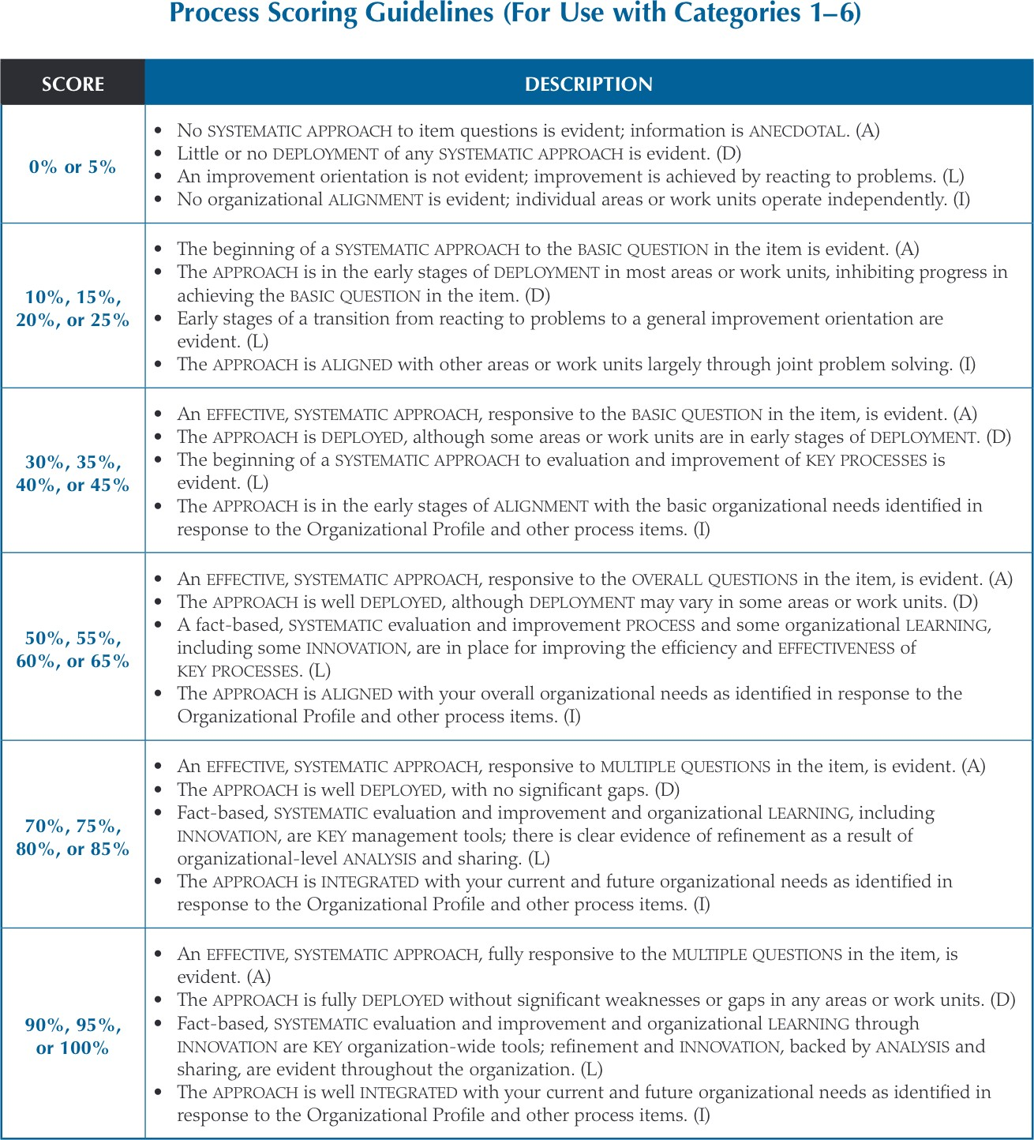

Page 32. Baldrige Performance Excellence Program. 2019. 2019–2020 Baldrige Excellence Framework: Proven Leadership and Management Practices for High Performance

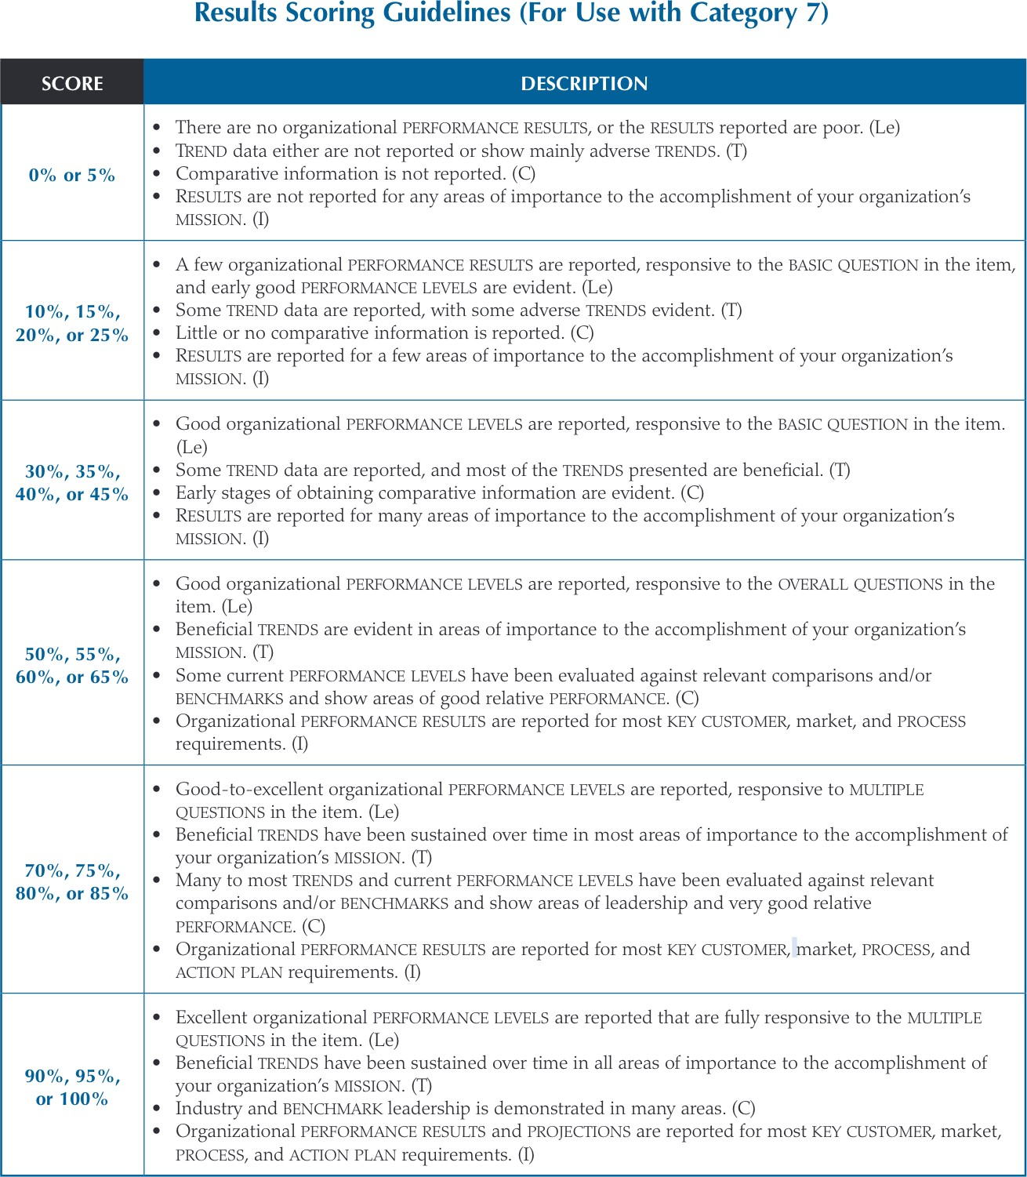

Page 33. Baldrige Performance Excellence Program. 2019. 2019–2020 Baldrige Excellence Framework: Proven Leadership and Management Practices for High Performance

Advisory Team
Public Health Emergency Opioid Epidemic
Dislocated Worker Training Grant

Protentional Organizational Structure 08/13/19
Revised 03/06/2020

