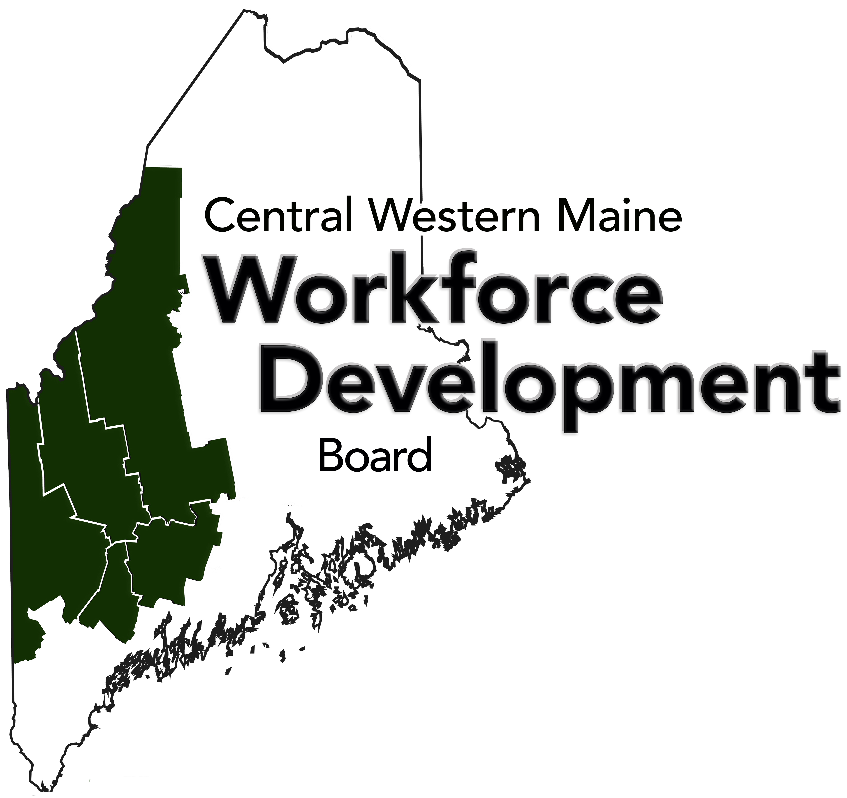
Central Western Maine Workforce Development Board
Chief Elected Official Meeting
Wednesday, January 5, 2022
8:30am-9:30am
Via Zoom Video Technology

Desired Results
1. Improve understanding of CEO Board roles and responsibilities to the CWM Region under WIOA.
2. Ensure all CEOs have the same operational information going into 2022 for CWMWDB and CWMWI.

AGENDA
- Call to Order Chair Sezak
- Review and Approve Last Meeting Minutes All
- Discuss Election Process for February/March - 8:35a Chair Sezak
- Accountant Update - 8:45a Chair Sezak, Ms. Flanders
- Overview of CEO Role in WIOA - 8:55a Ms. Flanders
- Discuss Relationship with MDOL/Service Provider - 9:10a All
- Performance Update - 9:20a Ms. Flanders
- Open Discussion/Any New Business - 9:25a All
- Adjourn Chair Sezak

Attachments
1. December 1, 2021 CEO Meeting Minutes
2. Proposed Contract with Sara McLaughlin (accountant)
3. WIOA and Local CEO Role
4. December 2021 Performance Packet
5. 2022 CEO Meeting Schedule

